**Grade 4**

**Place Value of Whole Numbers**

**Standards**

* 4.NBT.1: Recognize that in a multi-digit whole number, a digit in one place represents ten times what it represents in the place to is right..

**Rationale**

* Students gain a better understanding of our base-ten place value system. They investigate the relationship between the place value positions.

**Big Ideas**

* A digit is any one of the symbols 0, 1, 2, 3, 4, 5, 6, 7, 8 and 9 that are used to write numbers.
* The place position of a digit in a larger number affects the value of the digit.
* As you move along a place value chart from the right to the left, the value of each place is worth ten times more than the position to its right (for example, a 4 in the tens place is ten times more than a 4 in the ones column).
* As you move from the left to the right, the value of each place is worth ten times less than the place to its left.

x10

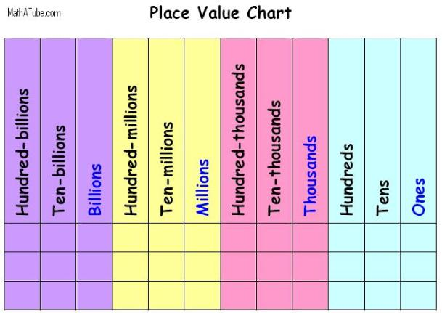

÷10

**Three Forms of Numbers**

* **Word Form:** a number written using words
* **Standard Form:** a number written using digits
* **Expanded Form:** a number written, which shows the value of each individual digit (beginning with the largest place)

**Example:**

* Standard Form: 4, 329, 857
* Word Form: four million, three hundred twenty-nine thousand, eight hundred fifty-seven.
* Expanded Form:

4,000,000 + 300,000 + 20,000 + 9,000 + 800 + 50 + 7

**Comparing and Rounding**

**Comparing:**

* Start at the largest place and move to the right, comparing each digit, one at a time.
* Use <, >, or = to compare numbers (example: 3,498,109 **<** 4,582,302)